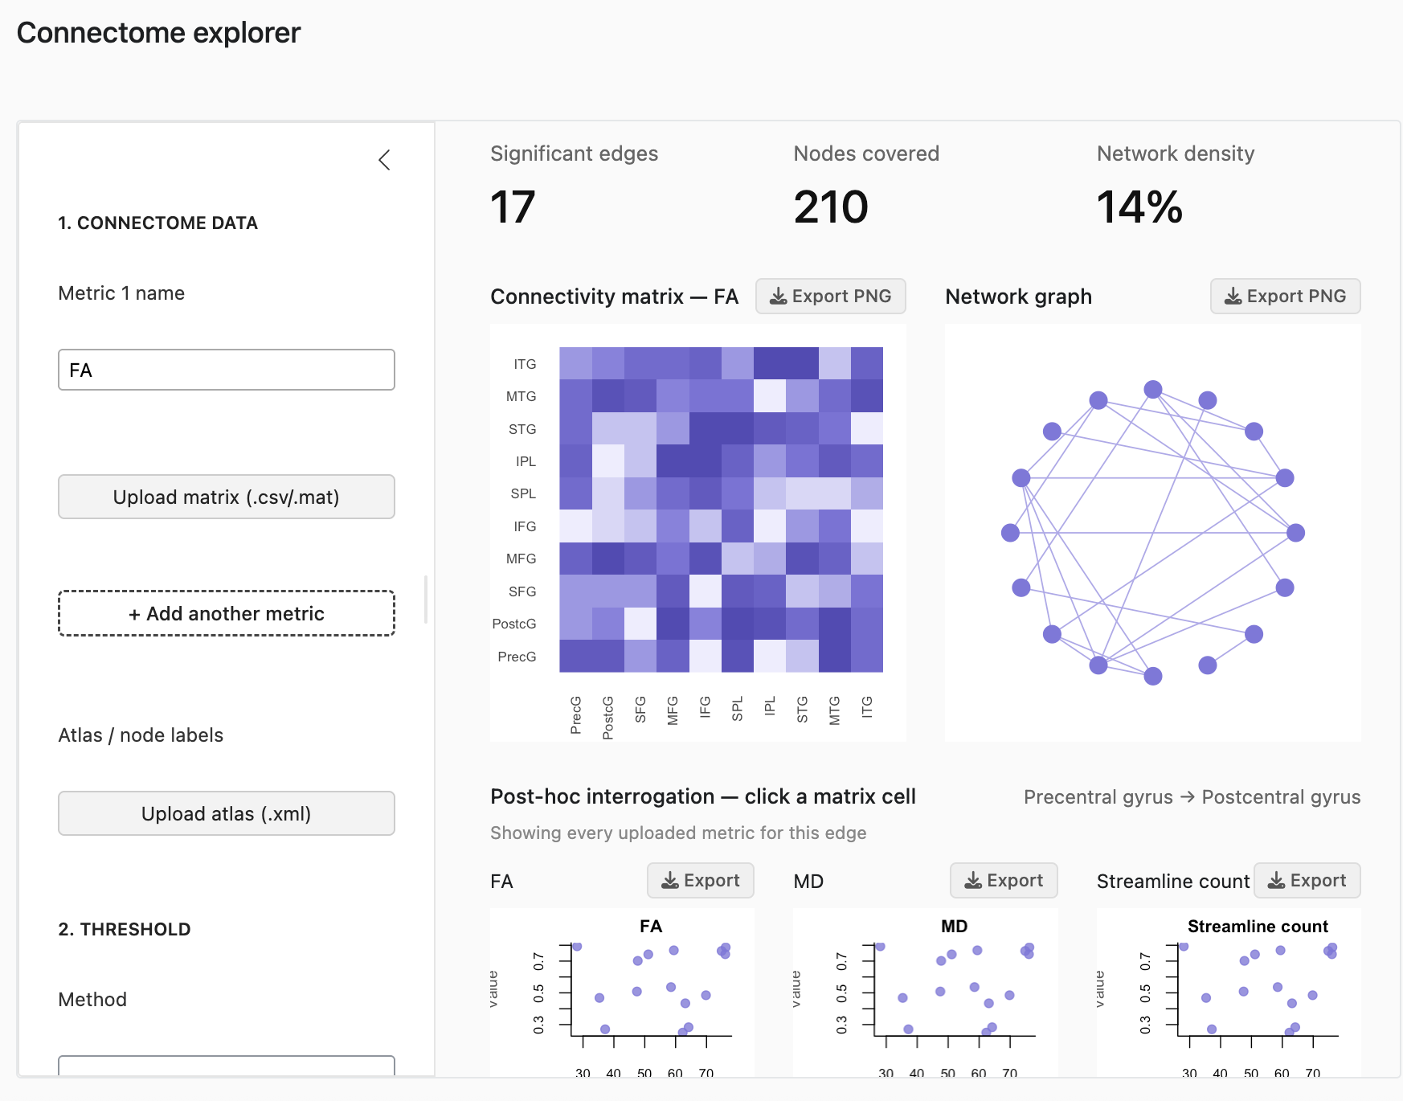

Design artefact explanation
This design artefact presents the interface architecture for a graphical user interface (GUI) supporting exploratory analysis of structural brain connectome data, developed as part of a thesis project addressing the lack of accessible, integrated tools for connectome thresholding, statistical analysis, and post-hoc data interrogation.
The artefact's scope is limited to the analysis stage of the connectome workflow: it assumes users arrive with pre-computed connectome matrices (e.g. FA, MD, streamline count) rather than raw diffusion MRI data. This decision was made in consultation with my supervisor, reflecting the practical constraint that raw tractography data can exceed 5–10GB per participant, making direct upload infeasible for typical cohort sizes (e.g. 142 participants). The tool is instead designed to accept standard matrix formats (CSV, MAT, R data frame) and an accompanying atlas file defining node labels, so that connectivity matrices display meaningful anatomical labels rather than numeric indices alone.
Three functional modules structure the sidebar, mirroring the three aims of the thesis: (1) data and metric upload, supporting multiple contrasts (FA, MD, AD) as separate, independently named datasets, since these represent distinct microstructural properties that cannot be meaningfully combined; (2) thresholding, offering consistency-based and density-based methods, with an optional upload path for a pre-computed p-value matrix (e.g. from Network-Based Statistics) to filter the display to statistically significant edges; and (3) statistics, which accepts a user-supplied design matrix rather than a single predefined outcome variable, allowing the tool to support arbitrary statistical models rather than being limited to one analysis type.
The main panel follows a progressive-disclosure structure: summary metric cards give an at-a-glance overview, the connectivity matrix and network graph provide two complementary visualisations of the same network, and a post-hoc interrogation panel allows users to click an edge and view its association with the outcome across every uploaded metric simultaneously. Each visualisation includes an individual export control, so that specific outputs can be downloaded independently for use in publications or presentations. In addition to graphical outputs, users will be able to export the underlying data itself: after applying a threshold, the resulting thresholded connectome matrices can be exported (e.g. as CSV files) for use in downstream statistical analyses such as Network-Based Statistics, rather than the tool being limited to producing figures alone.
Key risks and dependencies include variability in how existing pipelines format matrix outputs, which will require flexible file parsing; the computational cost of rendering large matrices interactively; and the need for a modular code structure (separate, independently testable components for upload, thresholding, statistics, and visualisation) so that individual features can be modified or extended without destabilising the rest of the application. The project is version-controlled using Git and hosted in a private GitHub repository, so that changes are tracked over time and development does not rely solely on a single local machine. This design will directly guide the next implementation stage, in which each module will be built and tested incrementally using R Shiny, beginning with data upload and matrix visualisation before adding statistical and interrogation features.

